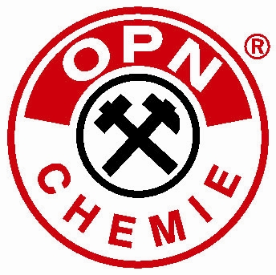
OPN-CHEMIE GmbH
Produktion techn. Aerosole - Sprays

In der Au 14, D-57290 Neunkirchen / Germany

Phone: +49 (0) 27 35 / 77 25-0 Fax: +49 (0) 27 35 / 77 25-90
www.opn-chemie.com info@opn-chemie.de

Product Information

OPN-High-Performance Cooling Lubricant
- Concentrate -

Properties:

- boron-free, containing mineral oil, containing amine
- to be used for machining steel, cast iron, high-alloy steels and aluminum
- stable emulsions with starting water from 10 ° dH to 30 ° dH
- emulsions are stable in use until water hardnesses of 60 ° dH
- good technical stability and long emulsion service life, when used properly
- good cooling and rinsing power
- good corrosion protection properties

Application Range:

- for general chipping such as turning, milling, drilling, sawing
- Can be used on single-filled machines as well as central systems

Application:

Our information are recommendations based on our experience. We accept no liability for any damage without tests concerning suitability for the specific application, without preliminary trials and if the products is misused. The emulsion is re-prepared by slowly pouring the concentrate into the initially prepared water while simultaneously stirring or by using automatic mixing equipment.
The recommended application concentration depends on the application and the materials to be processed:
Chipping of cast iron, steel and aluminum: from 6% (60 ml concentrate + 940 ml preparation water)
Medium to heavy chipping: from 8% (80 ml concentrate + 920 ml preparation water)
Concentration determination of the operating emulsion can be carried out by hand refractometer.
For this purpose, the indicated value is multiplied by the refractometer.
Always check the tendency to stain before machining aluminum alloys.
Shelf life / storage conditions:
12 months at a temperature of approx. 5 °C to about 40 °C in a closed container.
Protect from frost!
Note: Due to the raw materials, slight variations in appearance and color may be possible. These have no influence on the effect of the product.
Always observe the instructions of the machine manufacturer!
Only for professional use! Always observe safety data sheet before use.

Delivery information:

Art.-No. 58140 Disposable Canister: 5 liters content
Art.-No. 58141 Disposable Canister: 10 liters content
Art.-No. 58142 Disposable Canister: 20 liters content
Art.-No. 58143 Disposable Canister: 30 liters content
Art.-No. 58144 Disposable Barrel: 200 liters content

Observe the information on the label and of the EC-safety data sheet!

Our technical information has been compiled carefully to the best of our knowledge. Because of the many possible influences during processing and use of the products they do not relieve the processor of its own, conscientious exams! A legally binding assurance of certain properties or of the suitability for a particular purpose can not be derived from our information. Existing laws and regulations must be checked and observed from the processor of our products before use in his own responsibility.

All text passages are subject to the copyright of OPN-CHEMIE GmbH.

